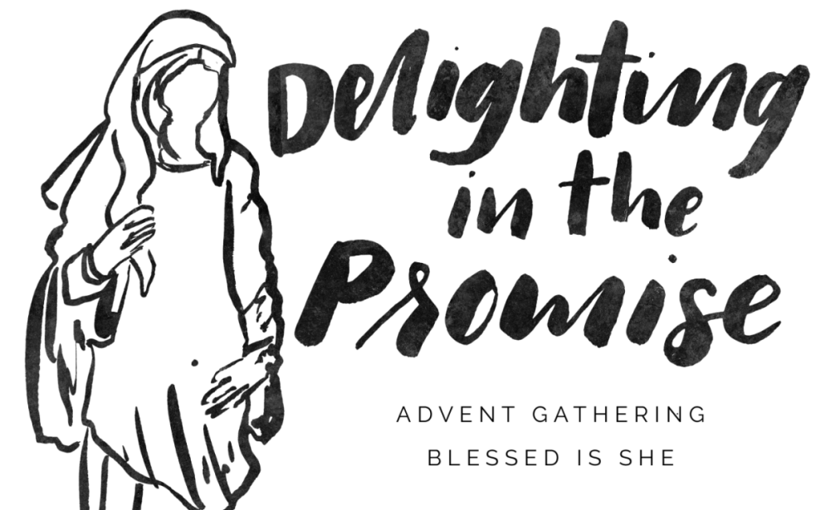

**Extended RSVP - Friday, Dec. 4th**

Please join the Whispering Winds Women’s Auxiliary on December 9th @ Our Mother of Confidence for an Advent mini retreat.

6:30 p.m. - Social in Serra Hall 7:00 - 8:30p.m. - Retreat

Our Mother of Confidence Church 3131 Governor Dr. San Diego, CA 92122

We will gather together, watch a virtual talk, and discuss reflection questions from our journals — all helping us prepare in the season of Advent for our Lord to fulfill the Promise at Christmas. To end the evening in style we’ll sing a few Christmas carols! Please bring a mother, sister, friend!

**‘Blessed Is She’ has far exceeded their expectations in presenting this retreat, Praise God!**

**Please register via phone to make sure we can provide you with your Advent Journal!**

**You may pay at the door - $20.00 (cash or check)**

RSVP: Carolyn Kalb 619-318-6493 or Judy Burke 619-562-4344