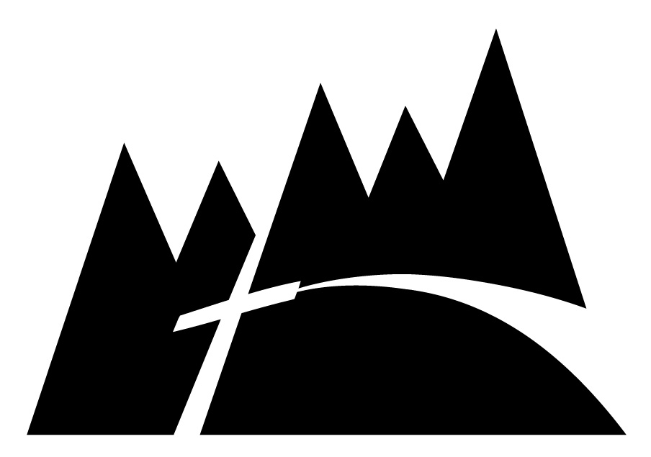

How to Make a Bequest to Whispering Winds

An excellent way for you to support Whispering Winds Catholic Conference Center Inc.’s mission is to leave us a bequest in your will, living trust or with a codicil. One significant benefit of making a gift by bequest is that it allows you to continue to use the property you will leave to charity during your life. Another benefit is that you are able to leave a lasting legacy.
Below are a number of ways you can make a bequest to Whispering Winds:
- A specific bequest involves making a gift of a specific asset such as real estate, stocks & bonds, other property, or a gift in a specific dollar amount. For example, you may wish to leave your home or $10,000.
- Another kind of specific bequest involves leaving a specific percentage of your overall estate to charity. For example, you may wish to leave 10% of your estate.
- A residual bequest is made from the balance of an estate after the will or trust has given away each of the specific bequests. A common residual bequest involves leaving a percentage of the residue of the estate to charity. For example, you may wish to leave 30% of the residue of your estate.
- A contingent bequest is made to charity only if the purpose of the primary bequest cannot be met. For example, you could leave specific property, such as a vacation home, to a relative, but the bequest language could provide that if the relative is not alive at the time of your death, the vacation home will go to Whispering Winds.

Benefits of Making a Bequest
Remembering Whispering Winds with a bequest from your estate will help sustain the ministry at Whispering Winds for generations to come. Some of the advantages of creating a bequest include:
- A bequest costs nothing now, yet gives you the joy of knowing you have provided for Whispering Winds in the future.
- You retain control of and use of your assets during your lifetime.
- A bequest is generally a revocable gift, which means you may modify it if your circumstances change.
- You can designate it for a purpose and have the peace of mind that your gift will be used as you intend.
- Bequests are exempt from federal estate taxes. If you have a taxable estate, the estate tax charitable deduction may offset or eliminate estate taxes, resulting in a larger inheritance for your heirs.
Sample Language
In order to make a bequest, you should speak with your attorney. Your attorney can help you include a bequest to Whispering Winds Catholic Conference Center, Inc. in your estate plan. We have provided some basic bequest language to assist you and your attorney.
Bequest of a Specific Dollar Amount
I hereby give, devise and bequeath _________ and No/100 dollars ($DOLLARS) to Whispering Winds Catholic Conference Center Inc., a nonprofit organization located at 8186 Commercial Street La Mesa CA 91942, Federal Tax ID # 95-3407343, for Whispering Winds Catholic Conference Center Inc.'s general use and purpose.
Bequest of Specific Real Estate
I hereby give, devise and bequeath all of the right, title and interest in and to the real estate located at ADDRESS OR DESCRIPTION OF PROPERTY to Whispering Winds Catholic Conference Center Inc., a nonprofit organization located at 8186 Commercial Street La Mesa CA 91942, Federal Tax ID # 95-3407343, for Whispering Winds Catholic Conference Center Inc.'s general use and purpose.
Percentage Bequest
I hereby give, devise and bequeath ____ percent (___%) of my total estate, determined as of the date of my death, to Whispering Winds Catholic Conference Center Inc., a nonprofit organization located at 8186 Commercial Street La Mesa CA 91942, Federal Tax ID # 95-3407343, for Whispering Winds Catholic Conference Center Inc.'s general use and purpose.
Residual Bequest
I hereby give, devise and bequeath to Whispering Winds Catholic Conference Center Inc., a nonprofit organization located at 8186 Commercial Street La Mesa CA 91942, Federal Tax ID # 95-3407343, ALL OR A PERCENTAGE of the rest, residue and remainder of my estate to be used for Whispering Winds Catholic Conference Center Inc.'s general use and purpose.
Contingent Bequest
If (primary beneficiary) does not survive me, then I hereby give, devise and bequeath to Whispering Winds Catholic Conference Center Inc., a nonprofit organization located at 8186 Commercial Street La Mesa CA 91942, Federal Tax ID # 95-3407343, DESCRIPTION OF PROPERTY to be used for Whispering Winds Catholic Conference Center Inc.'s general use and purpose.

Restricted Bequests
If you are considering a bequest but would like to ensure that your bequest will be used for a specific purpose, please let us know. We would be happy to work with you and your attorney to help you identify ways to give and meet your charitable objectives. We will also work with you and your attorney to craft language to accomplish your goals.
If you are making a restricted bequest, we recommend that your attorney include the following provision to give Whispering Winds Catholic Conference Center Inc. flexibility should it no longer be possible for our Whispering Winds Catholic Conference Center Inc. to use your gift as you originally intended:
If, in the judgment of the Board of Directors of Whispering Winds Catholic Conference Center Inc., it shall become impossible for Whispering Winds Catholic Conference Center Inc. to use this bequest to accomplish the specific purposes of this bequest, Whispering Winds Catholic Conference Center Inc. may use the income and principal of this gift for such purpose or purposes as the Board determines is most closely related to the restricted purpose of my bequest.

